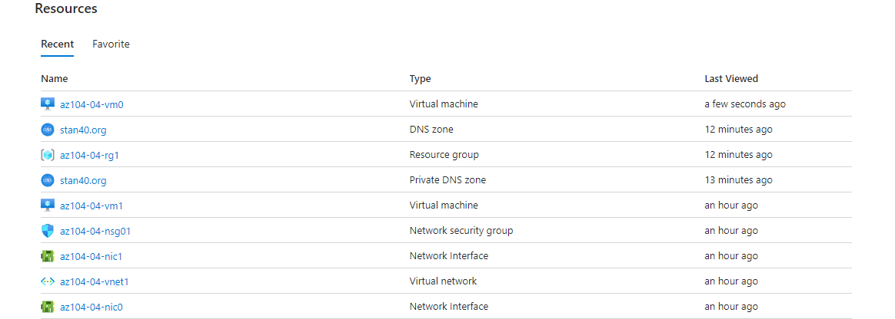**All resources created**:

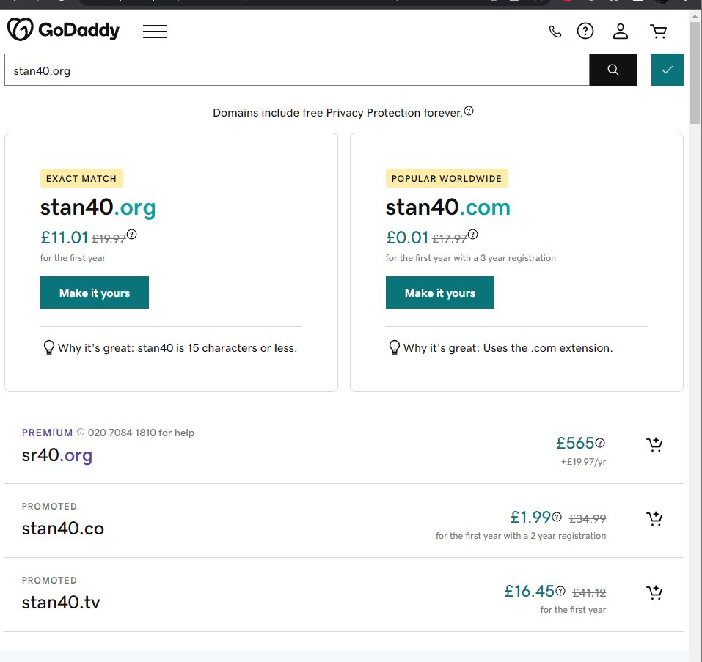**Checking in GoDaddy for a domain**:

**Name server**:

1. Verify that the output of the command includes the public IP address of **az104-04-vm0**.

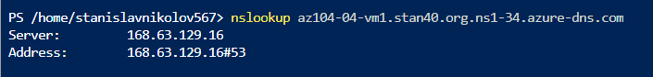

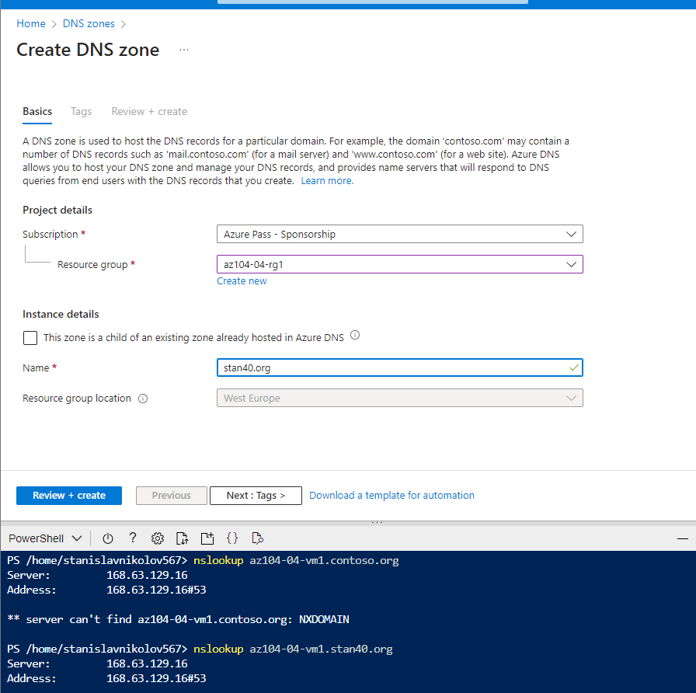**Creating DNS zone(public):**

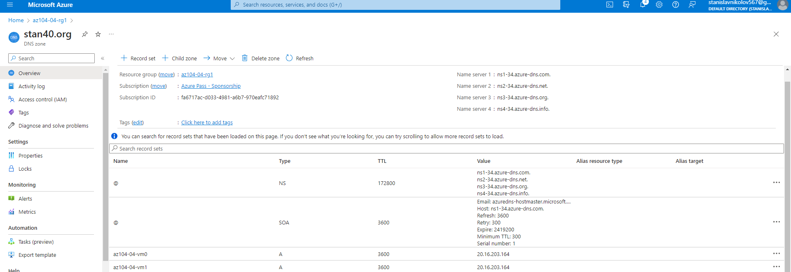**Overview in stan40.org:**